**APPLIED HYDROGEOLOGY**

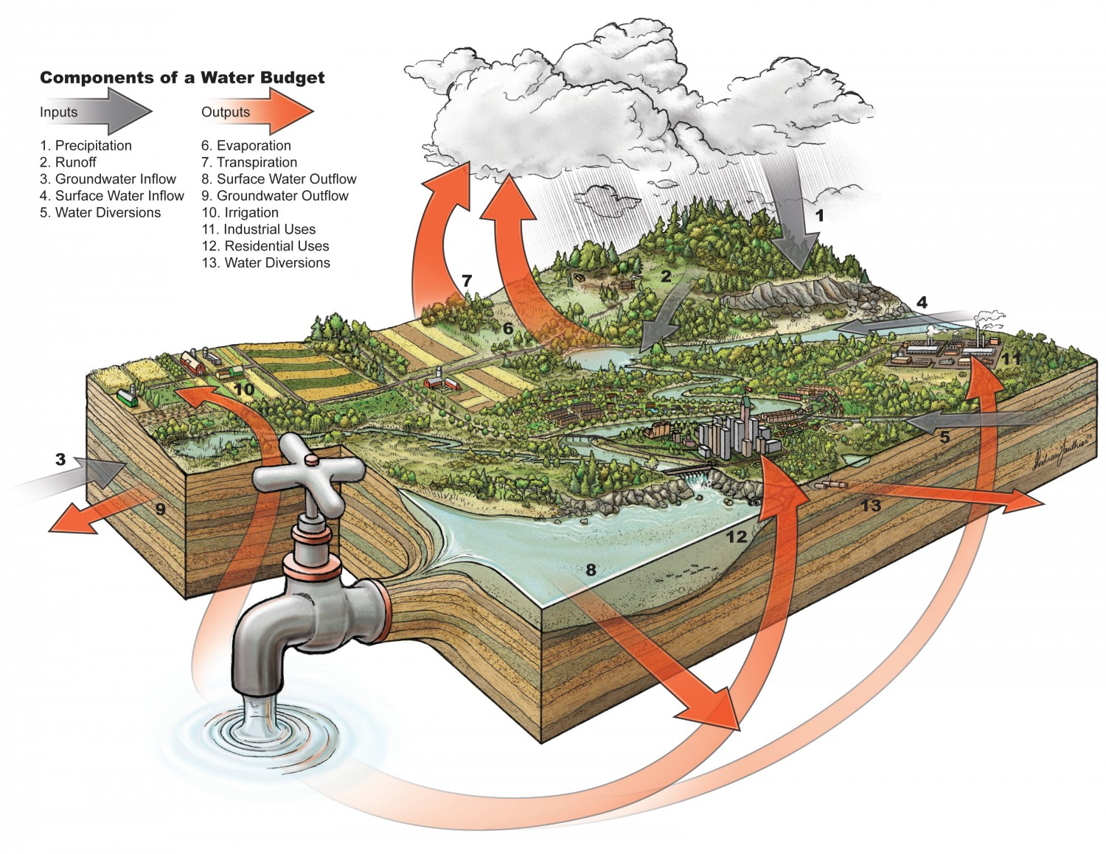

***Lecture 2: Estimating surface hydrologic processes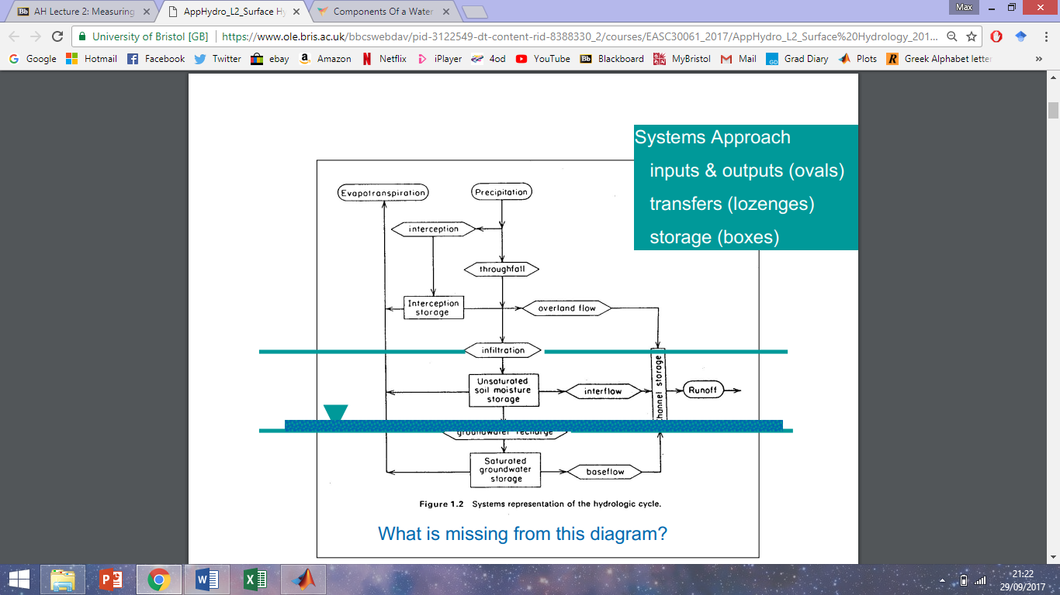 I***

Precipitation

* General features
* Best recorded hydrological parameter, long continuous records
* Main input to hydrological cycle
* Controls soil moisture, evapotranspiration, recharge and overland flows
* Varies considerably over space and time
* Precipitation type varies (large rain 🡪 small rain, snow, dew)
* Measurement
* Rain is collected by rain gauges with specific dimensions and site characteristics
* Water is repeatedly weighed and then discharged at set times
* Data often comes in the form of histograms due to this
* 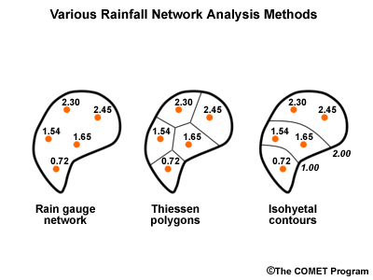Splash, wind turbulence, snow 🡪 recording issues
* Data has high temporal frequency but low spatial frequency, so it is often difficult to extrapolate between point data.
* 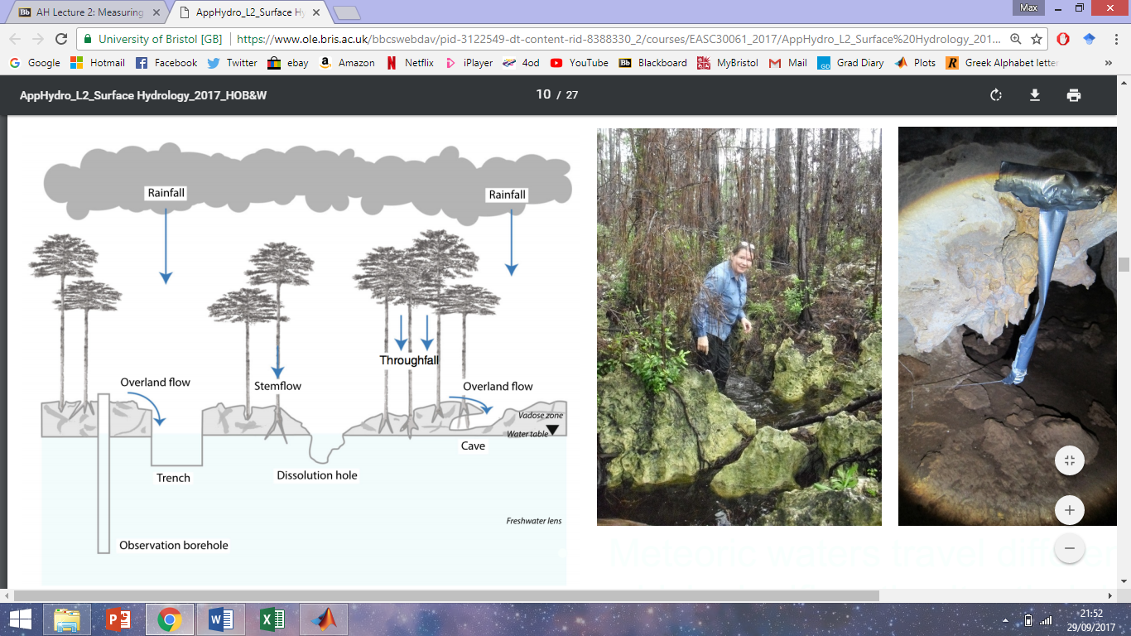**Doppler Weather Radar:** the most useful technique at our disposal. Various stations around the UK provide continuous spatial data. Rain drops, moisture and snow all reflect radiation – roughly proportional to the amount of precipitation. Best for short-term forecasting and understanding weather phenomena. Needs to be calibrated to ground data (rain gauges) since inaccuracies arise from wind-drift and droplet evaporation.
* **Satellites:** used to track weather systems over long distances. Cloud indexing (brightness, texture) can be related to precipitation through calibration and empirical measurement. Less accurate but good for filling gaps in data.
* **Interception and throughfall:** direct measurement of interception and throughfall can be obtained by using rain gauges above and below the canopy. Can be estimated on a site-by-site basis using the rate and duration of rainfall alongside empirical constants.
* **Stemflow** is organic-acid rich and acidic 🡪 drives dissolution of limestone surface and provides nutrients for microbial community

Evapotranspiration

* Evaporation
* Evaporation = molecules transitioning from (l) to (g) – molecules transitioning from (g) to (l)
* Rate of evaporation depends upon water temperature and air saturation
* Evaporation pans: typically 4 ft diameter, 20 cm depth. Water is kept at a constant depth (accounting for precipitation); the volume of water required is measured. Can often overestimate evaporation by overcorrecting for precipitation (evaporation tanks often at higher elevation). Warm much faster than large water bodies so must be corrected for (pan coefficient, varies spatially)
* Evapotranspiration
* Very hard to measure or quantify. Varies considerably with vegetation cover.
* A Lysimeter is used to track changes in soil moisture attributable to evapotranspiration, after accounting for precipitation, evaporation and drainage. Not ideal though as the Lysimeter scale is not sufficient to account for heterogeneities in vegetation cover. Also expensive and time consuming.
* Empirical techniques
* Always based upon previous observations
* Potential Evapotranspiration (PET) is derived from surface air temperatures and solar insolation, ignores vegetative effects (Thornthwaite)
* Energy budget techniques
* Equations for each component of the energy budget demand accurate measurement of parameters, often unavailable….
* The Bowen Ratio, in its simplest form: 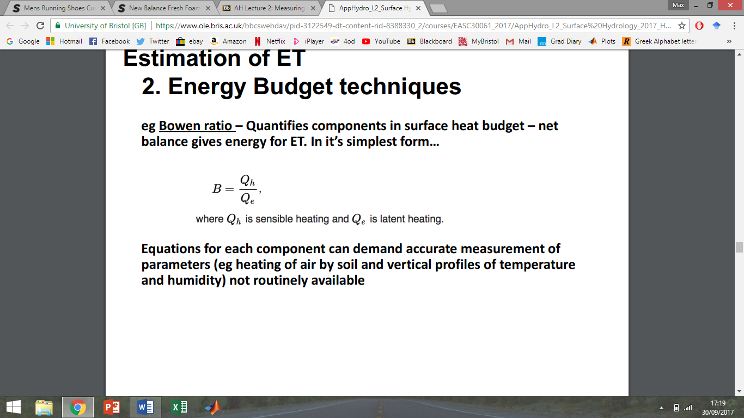
* Combined formula
* Combines the energy budget method with aerodynamics
* 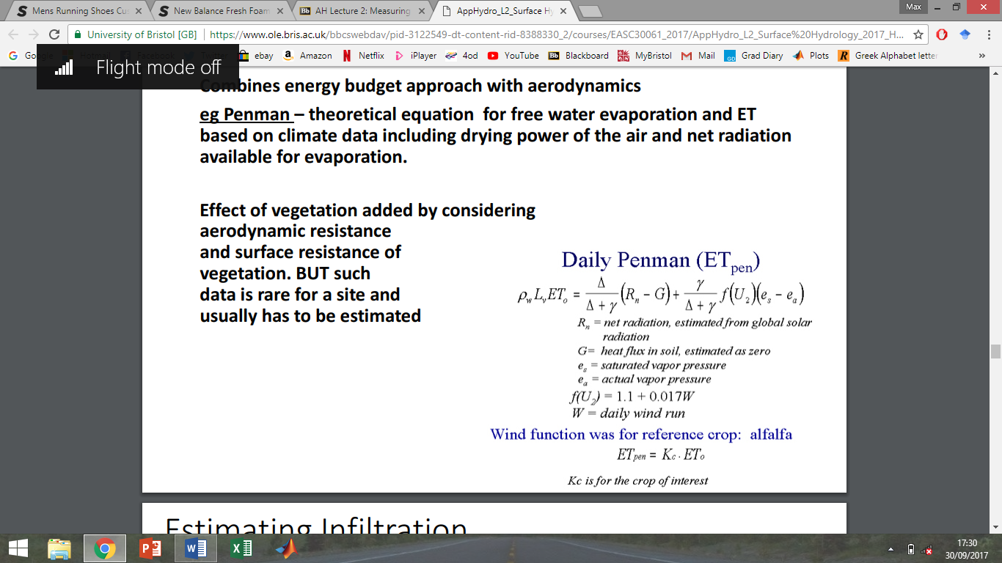The effect of vegetation is considered by considering aerodynamic resistance and surface resistance of vegetation. Such data is particular to sites and not widely available
* The Penman equation – theoretical equation for free water evaporation and ET based on climate data including drying power of the air and net radiation available for evaporation.

Infiltration

* Infiltration capacity, relative to rainfall intensity, determines run-off rate
* Measured using a double or single ring infiltrator
* Small-scale measurements often do not account for large-scale heterogeneities such as cavities in the ground. Necessary to repeat point measurements many times

Stream flow

* Stream-flow gauging
* Stream discharge = velocity x cross-sectional area
* Measuring velocity
* Measure at 60% depth or average from 20% & 80% depths
* Account for frictional retardation at the boundary
* Current meter or impellor
* Gauge stream in separate boxes and sum them
* Once a rating curve has been established velocity can be estimated by water level
* Water level (stage) is measured using a Munroe float, or ultrasonic/pressure gauges
* Fixed structures (weirs, flumes)
* Small and simple dam structures with low and high-flow openings of fixed/known dimension
* The weir causes increased water level (head) which is measured upstream. Flow rate through the weir is a function of the head and weir opening dimensions

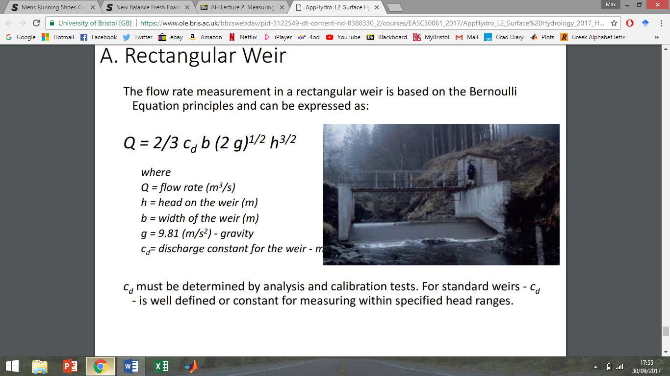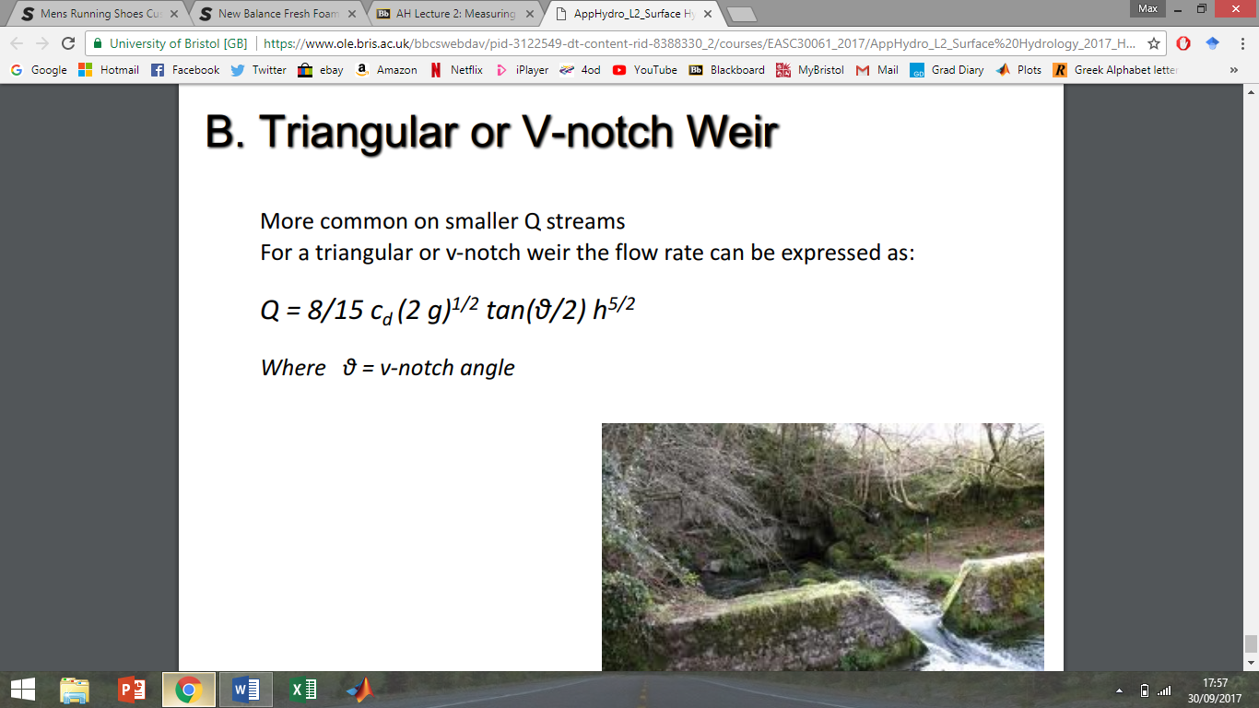

* Dilution gauging
* Time to centroid allows mean velocity to be calculated. This combined with cross-sectional area allows calculation of discharge.
* Salt easy tracer to use: no ecological impact, cheap, easy to record accurately
* Inject at steady rate over time. Conc will increase over time until constant. Constant is related to rate of injection and discharge.
* Gulf injection: dumping all of the tracer in at once 🡪 lag time 🡪 gradual rise, then a drop-off( unlike constant injection) 🡪 integrate area under curve 🡪 tie to centroid
* Time to centroid = 50% tracer has gone past 🡪 calculate average velocity. Turbulent mixing affects
* Distribution tends to be skewed to the right (+ time)
* Fluorescence as a tracer affected by biological activity

***Lecture 3: Estimating surface hydrological processes II + water budgets***

After precipitation 🡪 water level and discharge increase – rising limb 🡪 peak discharge 🡪 falling limb. There is flow in the river prior to precipitation (called GW or base flow). ‘Storm’ flow dominates following a precipitation event.

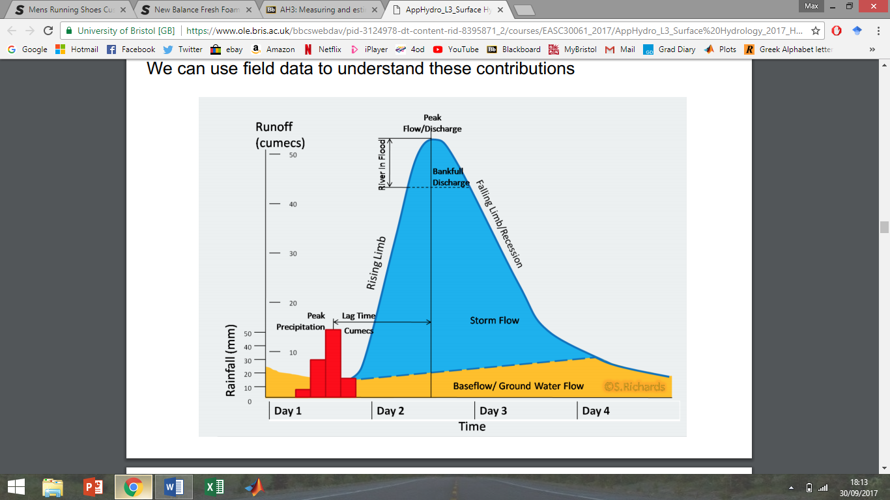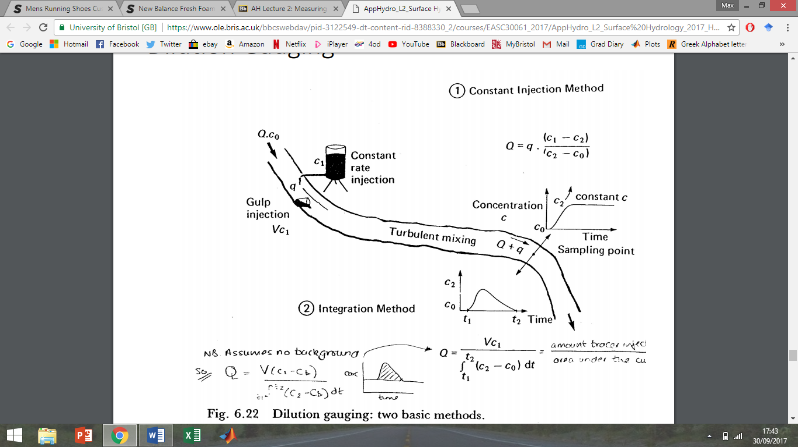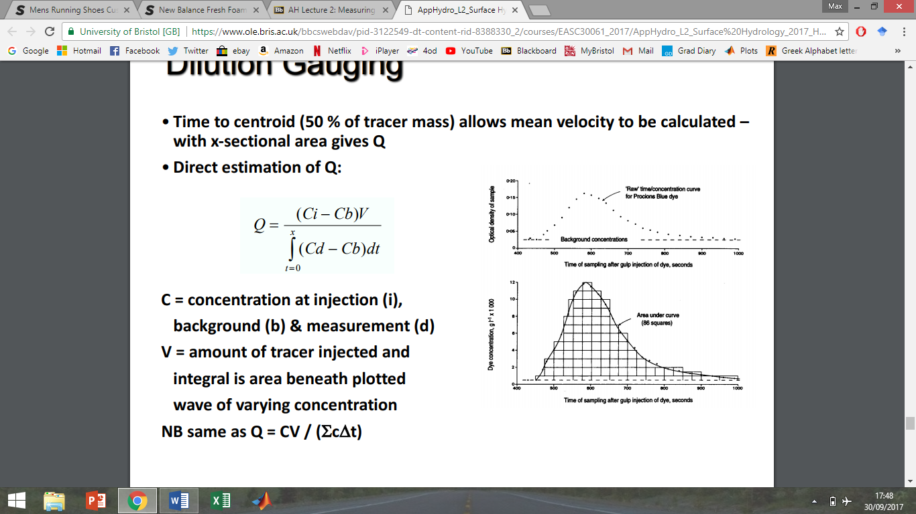

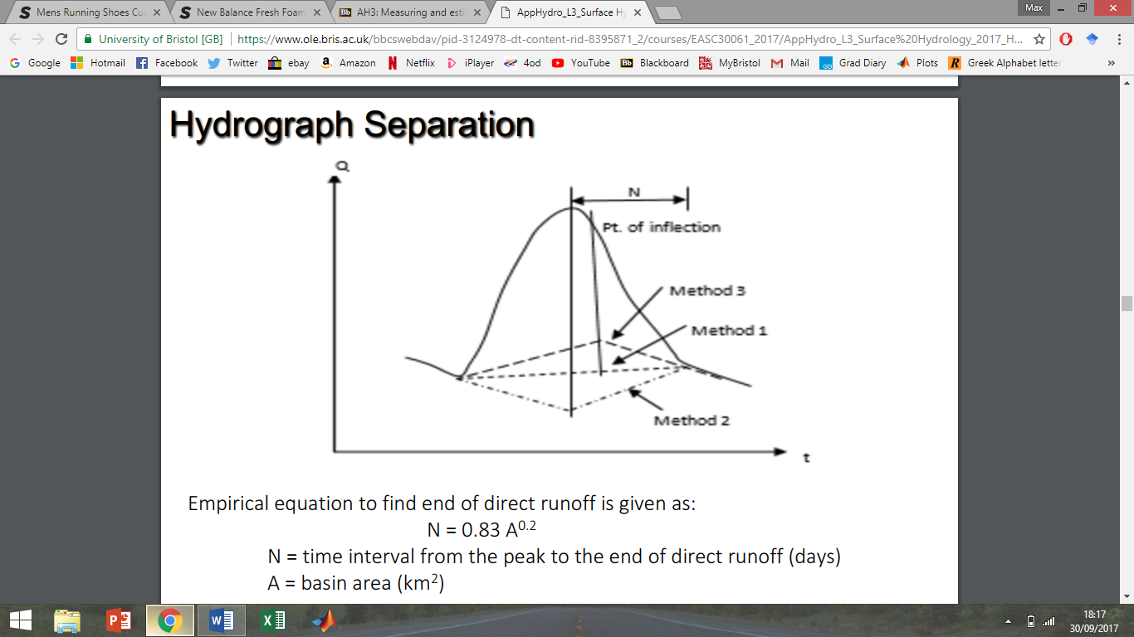

**Method 1** – Join the beginning of surface runoff to a point on the recession limb representing the end of direct runoff.

**Method 2** – Extend the base flow curve prior to the commencement of surface runoff until time of peak discharge. Join this point to the end point of direct runoff.

**Method 3** – Extend the base flow recession curve backwards after the depletion of flood water until it the time of the point of inflection. Join this point to the beginning of the surface runoff.

* If GW has distinct electrical conductivity, or TDS composition, mixing models (PHREEQC) can be used. Piston displacement flow = cave takes in flood water 🡪 pushing out the water within the cave, which has specific TDS from cave interaction 🡪 complicates chemical tracer
* Rational equation
* If it rains for long enough peak discharge will be a function of avg rate of precipitation over the basin multiplied by the basin area. Factors in GW and slow flowthrough

Hydrograph separation: separate storm flow from base flow. Exponential decrease in flow through time. time n is a function of the drainage basin area. Says nothing about drainage density. Method 1 involves drawing lines, mostly accurate but imperfect. Method 1 underestimates storm flow, so method 2 increases it. Method 3 uses a point of inflection, producing a lower quick flow.

* Q = C I A
* Runoff coefficient (C) depends upon land use. For any given land use, higher values usually uses for more intense storms.
* NOTE: works better in small catchments than large catchments
* Assumptions: rainfall rate and infiltration rate constant (best for small basins!) & duration of rainfall > time of concentration (doesn’t work well for flash events, which ruins assumptions!)
* ToC = time for water most distant from
* Manning equation:
* Predicts water velocity using slope, hydraulic radius ) (ratio between wetted perimeter: vol), and the Manning roughness coefficient (smoother channels 🡪 less friction)
$V= \frac{1}{n} R S$

* Surface-groundwater interaction: gaining and losing streams
* Gaining:
* Losing:
* Ground/surface wate interaction
* Interaction studied using GW models coupling saturated and unsaturated flow
* Where WT reaches the surface, creates source area for overland flow
* So we can predict the behaviour/occurrence of variable source areas and hence runoff
* Return flow = GW returning to surface
* Depression storage 🡪 surface overland floq
* Source areas vary though time
* Springs diagram is shit use another
* Important local source of water supply
* Spring discharge highly variable, may be constant or variable through time, vary in thermal/chemical evolution (characteristic about geology). Geologically related spring scenarios
* Water budgets
* Fundamental at many scales.
* Water balance equation for a terrestrial part of the hydrological cycle at any scale = P – E – T – Ro = dS
* P = precip, E = evap, T = transp, Ro = runoff
* Dynamic equilibrium assumed (recharge balanced by discharge and storage and position of the WT constant; dynamic eq. might occur over day-month-year timescales depending upon the individual system
* Water balance equation when considering exchanges with surface water and GW abstraction, expressed as:
* Rn + Qi – T – Qo – Qp = dS
* Rn = recharge to GW, Qo = outflow from GW storage to surface water, Qp = discharge due to well pumping (total pumping rate)
* Catchments often cross political boarders
* Different measurements in confined/unconfined aquifers… (for water level)
* Long island, NY 🡪 case study, use table to water budget. Do it for a later time

***Lecture 4: Groundwater***

* Montserrat Case Study:
* Eruption 🡪 exclusion zone and population relocation to the north 🡪 much of water supply was sources from volcanic springs 🡪 water pressure in the north
* Desk studies: rainfall and climate information, borehole data informing water table and stratigraphy (maybe even geophysics), satellite data (vegetation index, land-use, ash-fall), groundwater composition, digital elevation map, hydrological map detailing streams and springs (provide a point estimate of elevation of water table). Some data is much more reliable!
* Rainfall and vegetation cover maps used to model recharge rate
* Data gathering
* Desk study is the collation and review of information already available about a site, and is carried out
* Consider historical data, existing hydrogeological studies, identify gaps in knowledge!
* Surface features
* Topography: can indicate recharge areas and give general indications of flow system boundaries (NOT with confined aquifers)
* Surface water: lakes and rivers, discharge or recharge?
* Springs: location, discharge rates, chemistry
* Geology
* Understanding the stratigraphy and structure of an area is key to understanding hydrogeology
* Hydraulic heads
* Distribution of heads (water table in unconfined aquifer)
* Water balance
* Temperature gradients
* Groundwater chemistry
* Isotopes in groundwater
* Field reconnaissance
* Identifying sources of potential contamination and other issues
* Ground-checking secondary data to confirm it
* Talk to local people
* Field data collection
* Now we know where to drill the boreholes, drill the boreholes!
* Surveys of spatial distribution of physical and chemical characteristics
* Hydrological modelling
* A model is a simplified representation of an object, structure or process that cannot be studied directly because it is too large, too small, or too complicated, or because direct study/observation is not possible
* “prediction”: deterministic model, a unique set of input parameter values will generate a unique prediction. One possible outcome
* “forecast”: applied to deterministic models with a probabilistic component. Many possible outcomes.
* Permeability very difficult to model since it varies over 13 orders of magnitude
* “scale models” or “geometric models: represents the distribution of properties in 3D (faults, aquifers, beds, caves). Looks like a GW system but does not behave like one. Includes geological maps, cross sections,
* “process-based models”: more important to scientists since they can simulate physical processes. Must contain components of geometry and physical properties (porosity, weatherability etc.)
* “analogue models”: directly represent the processes in natural systems
* “stochastic models”: no attempt is made to directly represent the processes. Data, mathematical an statistical concepts link inputs to outputs. Techniques such as regression analysis.
* “deterministic models”: assumes a system’s behaviour is predetermined by physical laws.
* “analytical models”:
* IN ORDER TO SIMPLIFY A SYSTEM YOU MUST MAKE CERTAIN ASSUMPTIONS
* “numerical models”: area of interest is subdivided into many small areas (cells), the flow equation for each cell is replaced by a set of algebraic equations, solved numerically through an iterative process.
* Constructing a GW flow model
* MODFLOW makes use of spatial discretization
* Constructing simple finite difference models and writing a computer code to do the calculations is not too difficult
* Models can get very complex very quickly. All models are wrong, some are useful.

***Lecture 4: Porosity***

* Physical and chemical properties of water
* Cohesion and surface tension
* High heat capacity
* Latent heat transfer (vaporisation and fusion)
* Density
* Viscosity
* Universal solvent
* Porosity of geological material s
* Total porosity = fraction of the rock’s volume that is void space (n = VV/VT)
* A related parameter is the void ratio (e = VV/VS)
* Void ratio > porosity
* Can be expressed as a percentage or a ratio
* Types of porosity
* Primary and secondary porosity (pre- or post-rock formation)
* Inter- and intra-granular porosity
* Total and effective porosity (effective is a small fraction of total)
* Total and effective porosity
* Continuum: micro-pores to large pores
* Very vague definitions of the size of these pores
* All pores have the potential to transmit water. The smaller the pore, the less able water is to travel through it (due to surface tension)
* Effective porosity = the volume of voids that are interconnected and this can transmit water
* Sandstones and shales have the greatest effective porosity
* Determination of porosity
* By volume: oven dried sample is weighed 🡪 then saturated and weighed again 🡪 water volume is recorded. Gas often used instead of water.
* By weight: based on relationship between bulk density and particle density
* Optical methods: ara of the material vs area of voids visible in thin section. Assumes ‘areal’ and ‘volumetric porosities are equal 🡪 not appropriate for more 2D minerals!
* CT scan: 3D image of pore structure
* Porosity of sediments
* Maximum and minimum porosity increases as the grain size decreases
* **Not due to grain size! Porosity is largely independent of grain size**
* Packing: cubic packing (47.65%) vs rhombohedral packing (25.95%)
* The porosity of well-rounded and well-sorted sediments is independent of grainsize and varies with packing from 26 – 48%
* Sorting: well-sorted sediments have greater porosity than poorly-sorted sediment
* Clay-rich sediments have the greatest porosity due to chemical properties
* Diagenesis: porosity of sedimentary rocks
* Diagenesis alters composition and texture, but also porosity and permeability, via compaction and chemical reaction
* Formation of cement between grains reduces permeability
* Compaction: bulk volume is reduced at the expense of pore volume by 1) dewatering and packing 2) local fracturing and grain bending 3) pressure solution
* Muds have high depositional porosity but compact rapidly by dewatering and dehydration of clays
* Sandsones are more resistant to companion, with a linear reduction in porosity with depth
* Shales are often aquicludes
* Why is there an offset between the model and the real data? Real aquifers have approx. 10% less
* Chemical reactions: 1) dissolution 2) precipitation 3) stabilisation of minerals
* Chemical reactions: particularly important in carbonates and evaporites (very reactive). Processes are largely dependent upon fluid circulation 🡪 important feedbacks!
* Different chemical reactions generate a variety of pore types. Fabric selective/dependent.
* Critical Qu is the degree to which porosity is effective
* % Quartz vol. increases with weathering. For a given grain type, porosity increases with weathering. Increasing textural maturity due to increased sorting and rounding.
* Karstification increases porosity and permeability
* Scale-dependence of porosity
* Porosity is highly heterogeneous so the scale of measurement is important
* REV = Representative Elementary Volume: the volume that is large enough to accurately represent a sediment or rock
* Porosity of plutonic and metamorphic rocks
* Very low primary porosity
* Secondary porosity is dominant. Generated by fracturing and weathering.
* Rapid weathering of a granite can generate significant porosity
* Volcanics: volatile volcanics often have very high porosity
* Pyroclastics: very high porosities!
* Tuffs: the top and the base maintain high porosity (fast cooling), whilst the interior loses porosity through dense welding (slower cooling)